Allergens |  | Starters |  |  |  |  | Mains |  |  |  |  | sides |  |  |  |  | Desserts
 | Bread & olives | Cauliflower | Pea soup | Mackerel | Pork belly | Red lentil dahl | Lamb | Cod | Butternut Dahl | Duck Leg | Pork | Garlic potatoes |  |  | Fondant carrots | Smoked Potato |  | Delice | Sticky toffee | Ice cream | Cheese board
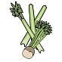Celery |  |  | x |  | X |  | x | x |  | x | x |  |  |  | x |  |  |  |  |  | x
Cereals containing gluten** | x |  | x |  | X |  |  |  |  | x |  |  |  |  |  |  |  |  | x |  | x
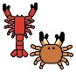  Crustations |  |  |  |  |  |  |  | x
Eggs |  |  |  |  |  | x |  |  |  |  |  |  |  |  |  |  |  | x | x | x
Fish |  |  |  | x |  |  |  | x
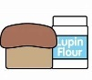  Lupin | x |  | x |  |  |  |  |  |  |  |  |  |  |  |  |  |  |  |  |  | x
Milk | x |  | x |  |  | x | x | x |  | x | x |  |  | x | x | x |  | x | x | x | x
Molluscs |  |  |  |  |  |  |  | x
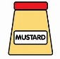  Mustard |  |  |  |  |  |  |  | x
Nuts* |  |  | x |  |  |  | x |  |  | X | x |  |  |  |  |  |  | x | x |  | X
Peanuts |  |  | x
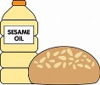  Sesame Seeds | x |  |  |  |  |  |  |  | x
Soya |  |  |  |  | x
Sulphur Dioxide |  |  | x | x |  |  | x | x |  | x | x |  |  | x |  |  |  | x
Evening Menu
Appetizers

Artisan baked bread, roasted garlic hummus, garlic & rosemary olives (V) £8.50
Starters
Garden pea and mint soup, candied hazelnuts £7.50
Red lentil, spinach & sweet potato dahl, crispy egg (V/VE) £8.50
Cured mackerel, pickled grapes, cucumber, buttermilk dressing, parsley & dill oil £9.00
Pan roasted Indian spiced cauliflower and curried peas; yoghurt dressing (V/VE) £8.50
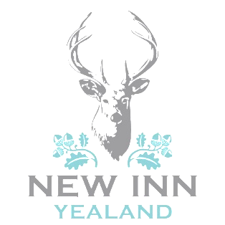
Asian inspired pork belly, sweet and sticky soy and ginger sauce, pickled vegetables £8.50
Mains
Best end of pork served with thyme and garlic baby potatoes, tenderstem broccoli, pickled apple,
rhubarb gel, spring greens £21.00
Confit duck leg served on creamy polenta, seasonal veg, plum compote and candied hazelnuts £22.00
Pan fried cod, curried potato & vegetable chowder with mussels £21.50
Red lentil, spinach, sweet potato & butternut squash dahl topped with a crispy egg (V/VE) £16.00
Pulled lamb, garlic mashed potato, parsnip puree, mint pesto, tenderstem broccoli,
spring greens, candied hazelnuts £23.00
Pan roasted Indian spiced cauliflower and peas, yoghurt dressing (V/VE) £16.00
Sides
Smokey mashed potato, infused with garlic and rosemary (V) £5.00
Fondant carrots slow cooked in chicken stock £5.00
Roast baby potatoes with garlic oil (V/VE) £5.00
Desserts

Chocolate delice, caramelised almond sugar, raspberry sorbet £8.00
Sticky toffee pudding, toffee sauce, caramelised banana (V) £8.00
Affogato – Vanilla ice cream, amaretto, espresso shot £7.00
Selection of Walling’s Ice cream and sorbets (V) £2.00 (per scoop)
Cheese board – County trio cheese board, Flakebridge Eden smokey, Mrs Kirkham’s Lancashire
and Garstang Blue with artisan crackers, sweet chutney relish, celery, apple and grapes £11.50

Please ask a member of the team to see our range of accompanying dessert wine or ports
A selection of liqueur coffee also available on request

GF – can be made gluten free/VE – vegan alternative available please turn over for allergen information
FOOD ALLERGIES AND INTOLERANCES
Some of our foods contain allergens. Please speak to a member of staff for more information.
All prices are inclusive of VAT

