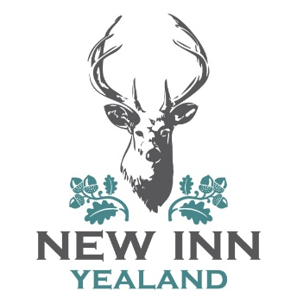

Children’s Menu
Starters
Fish goujons, ketchup
Butternut Squash soup
Carrot sticks & hummus
All £3.00
Mains
Sausage
Mini fish
Roast chicken
Served with mash, fries, peas, seasonal veg
All £6.00
Desserts
Sticky toffee pudding, toffee sauce, vanilla ice cream £3.50
Ice cream £2.50

